**Spring Framework**

Spring framework is **an open source Java platform that provides comprehensive infrastructure support for developing robust Java applications very easily and very rapidly**. Spring framework was initially written by Rod Johnson and was first released under the Apache 2.0 license in June 2003. **It is Modular Framework.**

**The Spring Framework is an application framework and inversion of control container for the Java platform**. The framework's core features can be used by any Java application, but there are extensions for building web applications on top of the Java EE (Enterprise Edition) platform. Although the framework does not impose any specific programming model, it has become popular in the Java community as an addition to the Enterprise JavaBeans (EJB) model.

**Spring Architecture:**

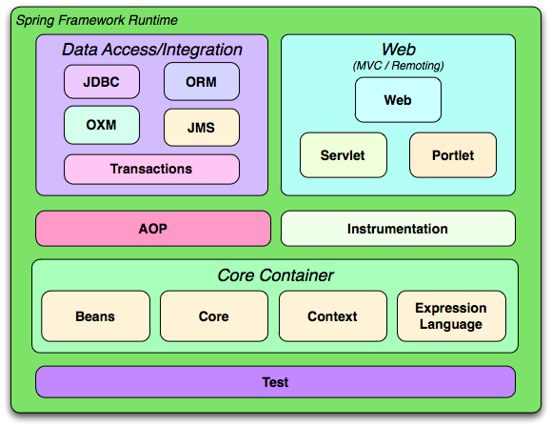

The Spring framework consists of seven modules which are shown in the above Figure. These modules are Spring Core, Spring AOP, Spring Web MVC, Spring DAO, Spring ORM, Spring context, and Spring Web flow. These modules provide different platforms to develop different enterprise applications; for example, you can use Spring Web MVC module for developing MVC-based applications.

#### Spring Framework Modules

* **Spring Core Module:**   
  The Spring Core module, which is the core component of the Spring framework, provides the IoC container There are two types of implementations of the Spring container, namely, **bean factory and application context**. Bean factory is defined using the org.springframework.beans.factory.BeanFactory interface and acts as a container for beans. The Bean factory container allows you to decouple the configuration and specification of dependencies from program logic. In the Spring framework, the Bean factory acts as a central IoC container that is responsible for instantiating application objects. It also configures and assembles the dependencies between these objects. There are numerous implementations of the BeanFactory interface. The XmlBeanFactory class is the most common implementation of the BeanFactory interface. This allows you to express the object to compose your application and remove interdependencies between application objects.
* **Spring AOP Module:**   
  Similar to Object-Oriented Programming (OOP), which breaks down the applications into hierarchy of objects, AOP breaks down the programs into aspects or concerns. Spring AOP module allows you to implement concerns or aspects in a Spring application in Spring AOP, the aspects are the regular Spring beans or regular classes annotated with @Aspect annotation. These aspects help in transaction management and logging and failure monitoring of an application. For example, transaction management is required in bank operations such as transferring an amount from one account to another Spring AOP module provides a transaction management abstraction layer that can be applied to transaction APIs.
* **Spring ORM Module:**   
  The Spring ORM module is used for accessing data from databases in an application. It provides APIs for manipulating databases with JDO, Hibernate, and iBatis. Spring ORM supports DAO, which provides a convenient way to build the following DAOs-based ORM solutions:
  + Simple declarative transaction management
  + Transparent exception handling
  + Thread-safe, lightweight template classes
  + DAO support classes
  + Resource management
* **Spring Web MVC Module:**   
  The Web MVC module of Spring implements the MVC architecture for creating Web applications. It separates the code of model and view components of a Web application. In Spring MVC, when a request is generated from the browser, it first goes to the DispatcherServlet class (Front Controller), which dispatches the request to a controller (SimpleFormController class or AbstractWizardformController class) using a set of handler mappings. The controller extracts and processes the information embedded in a request and sends the result to the DispatcherServlet class in the form of the model object. Finally, the DispatcherServlet class uses ViewResolver classes to send the results to a view, which displays these results to the users.
* **Spring Web Flow Module:**   
  The Spring Web Flow module is an extension of the Spring Web MVC module. Spring Web MVC framework provides form controllers, such as class SimpleFormController and AbstractWizardFormController class, to implement predefined workflow. The Spring Web Flow helps in defining XML file or Java Class that manages the workflow between different pages of a Web application. The Spring Web Flow is distributed separately and can be downloaded through [http://www.springframework.org](http://www.springframework.org/) website.  
  The following are the advantages of Spring Web Flow:
  + The flow between different UIs of the application is clearly provided by defining Web flow in XML file.
  + Web flow definitions help you to virtually split an application in different modules and reuse these modules in multiple situations.
* **Spring Web DAO Module:**   
  The DAO package in the Spring framework provides DAO support by using data access technologies such as JDBC, Hibernate, or JDO. This module introduces a JDBC abstraction layer by eliminating the need for providing tedious JDBC coding. It also provides programmatic as well as declarative transaction management classes. Spring DAO package supports heterogeneous Java Database Connectivity and O/R mapping, which helps Spring work with several data access technologies. For easy and quick access to database resources, the Spring framework provides abstract DAO base classes. Multiple implementations are available for each data access technology supported by the Spring framework. For example, in JDBC, the JdbcDaoSupport class and its methods are used to access the DataSource instance and a preconfigured JdbcTemplate instance. You need to simply extend the JdbcDaoSupport class and provide a mapping to the actual DataSource instance in an application context configuration to access a DAO-based application.
* **Spring Application Context Module:**   
  The Spring Application context module is based on the Core module. Application context org.springframework.context.ApplicationContext is an interface of BeanFactory. This module derives its feature from the org.springframework.beans package and also supports functionalities such as internationalization (I18N), validation, event propagation, and resource loading. The Application context implements MessageSource interface and provides the messaging functionality to an application.

#### How to download and install Spring framework

1. For Downloading Spring Repository you need to visit <https://repo.spring.io/release/org/springframework/spring/>. In this website, you will find different spring framework releases. You have to click on latest framework release. Here you will find three files which are:
   * spring-framework-5.2.8.RELEASE-dist.zip
   * spring-framework-5.2.8.RELEASE-docs.zip
   * spring-framework-5.2.8.RELEASE-schema.zip
2. For Installing, You need to extract the “spring-framework-5.2.8.RELEASE-dist.zip” file in your any drive. Now you are able to run your application in spring framework.

#### Spring Framework Advantages :

### Pre-defined Templates

Spring framework contains various types of templates for Hibernate, JDBC, and JPA technologies. With the help of this approach, developers are not required to define complex code.

Example: JdbcTemplate - Here, we do not need to write the logic for creating a statement, committing the transaction, creating a connection, and exception handling. It saves the time-consuming approach.

### Loose Coupling

We can consider Spring applications to be loosely coupled as per the dependency injection mechanisms.

### Easy and Simple to Test

It is easy to test the entire application using a spring framework with a dependency injection mechanism. The EJB or Struts application requires the server to execute the application.

### Non-invasive

As per the Plain Old Java Object (POJO) technique, Spring is easy to implement as it does not force the developer to inherit certain classes or implementations on any interface.

### Fast Development

With the help of Dependency Injection, it is easy to integrate the framework and support the development of JavaEE-based applications.

### Strong Abstraction Support

Spring supports the strong abstraction capability for Java EE-based specifications, such as JMS, JDBC, JPA, and JTA.

### Spring's Web Framework is Well-Organized

It is a web [MVC framework](https://www.simplilearn.com/tutorials/dot-net-tutorial/mvc-architecture) that delivers a fantastic option to web frameworks for developing applications using Struts or different widespread web frameworks.

### Spring Delivers a Suitable API

It translates technology-specific anomalies thrown by JDBC, Hibernate, or JDO into uniform, uncontrolled exceptions.

### Lightweight IoC

It is lightweight, particularly when compared to EJB containers, for example. This helps create and deploy applications on computers with restricted memory and CPU resources.

### Constant Transaction Management

Spring provides an interface that can help scale down to a local transaction (for example, using a single database) and scale up to global transactions (for example, JTA).